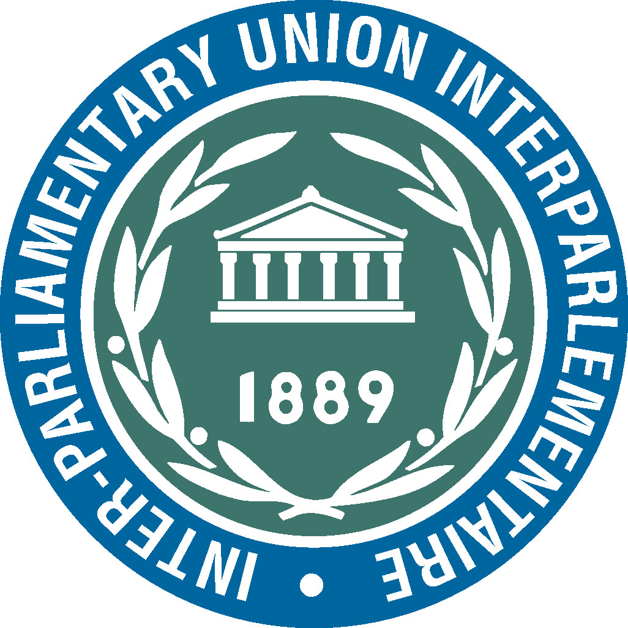 | 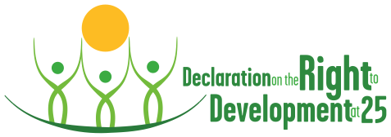  PROMOTING THE RIGHT TO DEVELOPMENT:  THE ROLE OF PARLIAMENT | 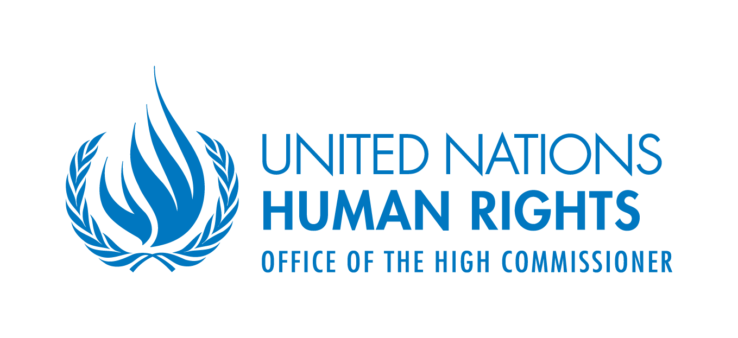
Seminar organized by
the Inter-Parliamentary Union (IPU) and the Office of the United Nations High Commissioner for Human Rights (OHCHR)
Bern, 20 October 2011

PROGRAMME

8.45 - 9.30 a.m. | Registration
9.30 - 9.45 a.m. | Welcoming remarks by UPR and OHCHR
9.45 - 11 a.m. | - What is the right to development?  Presentation: (Mr. Craig Mokhiber, Chief, Development and Economic and Social Issues Branch, OHCHR)  The right to development is a human right which finds its root in the UN Charter, Universal Declaration of Human Rights and both international covenants on civil and political rights, as well as social, economic and cultural rights. This right has been enshrined in United Nations Declaration on the Right to Development (4 December 1986) and recognized as universal and inalienable human right in many other UN documents including the Vienna Declaration and Programme Action and the MDGs Review Summit Outcome.  This presentation will give a brief overview of the origin of this right, explain what it consists of, and identify requirements for its realization. It will also identify achievements and constraints  - Debate  - Promoting human rights from a development perspective  Presentation: (Professor Stephen Marks, Harvard University; former Chairperson of the United Nations high-level task force on the implementation of the right to development)  What added value does the right to development bring to the implementation of civil, political, economic, social and cultural rights and vice versa?  This presentation will serve to dispel misconceptions about which is more important, human rights or development. It will illustrate that both are interlinked and indissociable. The presentation will also deal with effective implementation of the right to development and how to gauge its impact  - Debate
11 - 11.15 a.m. | Coffee break

- Ensuring equal implementation of the provisions of the International Covenant on Civil and Political Rights and the International Covenant on Economic, Social and Cultural Rights in order better to promote the right to development

Effective implementation of the provisions of these two Covenants contributes to realization of the right to development as an expression of public rights and freedoms. The need for a stronger national and global partnership as well as international cooperation and solidarity will be emphasized as essential to realizing the right to development

11.15 a.m. - 1 p.m. | - Giving full effect to civil and political rights for enhanced realization of the right to development  Presentation: (Mr. Alfred de Zayas, Professor of international law at the Geneva School of Diplomacy and International Relations)  Specific examples will be provided to illustrate how the effective implementation of civil and political rights, and in particular fundamental freedoms, has helped promote the right to development. Hurdles encountered along the way will be identified  - Debate
1 p.m. - 2.30 p.m. | Lunch
2.30 - 3.30 p.m. | - Implementing the right to development through full respect for economic, social and cultural rights, notably the guarantee of meeting basic needs  Presentation: Mr. Zdzislaw Kedzia, member of the United Nations Committee on Economic, Social and Cultural Rights  This presentation will follow in the steps of the previous one. Basic needs, including guaranteed food security, broad coverage of health-care needs and a good education.  - Debate
3.30 - 3.45 p.m. | Coffee break
3.45 - 5.15 p.m. | - Parliaments’ contribution to the promotion of the right to development: Formulating, adopting and effectively implementing measures to ensure full realization of the right to development  Presentation: Ms. Saumura Tioulong, MP (Cambodia)  This presentation will outline parliaments’ role in realizing this right. Examples of parliaments will be provided to illustrate how legislators can contribute to ensuring respect and promotion of this right, including their involvement in the development aid process  - Debate
5.15 - 5.30 p.m. | Close of the seminar

